The memory card is unable to record. Please perform a full format.

If StreamCenter is unable to recognize the format, causing the memory card to be unable to record, please follow the steps below to format the card.

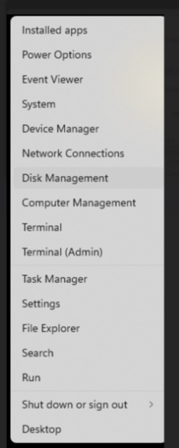
Figure 1. Access Disk Management"

Right-click on 'Start' and open Disk Management as shown in Figure 1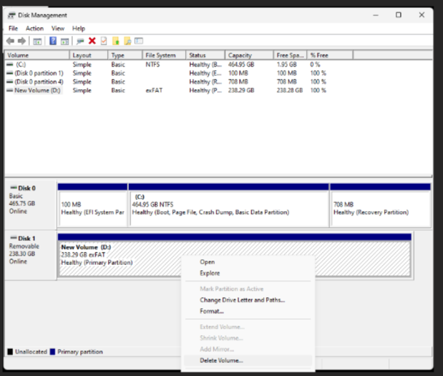
Figure 2. Delete the partition on the memory card.

Scroll down to locate the unrecognized memory card, right-click on it, and select 'Delete Volume' as shown in Figure 2.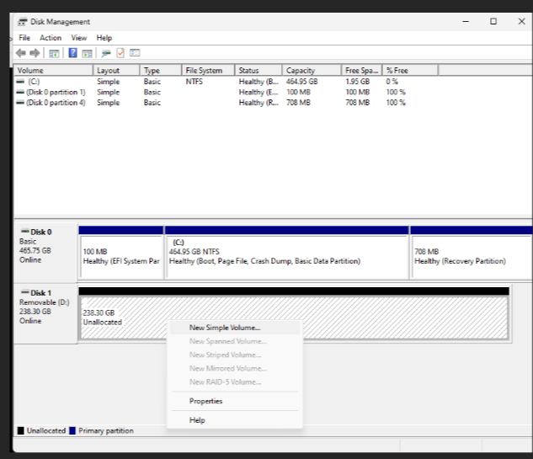
Figure 3. Create a New Partition.

After deletion, the memory card will show as unallocated. Right-click on it and select 'New Simple Volume' as shown in Figure 3。
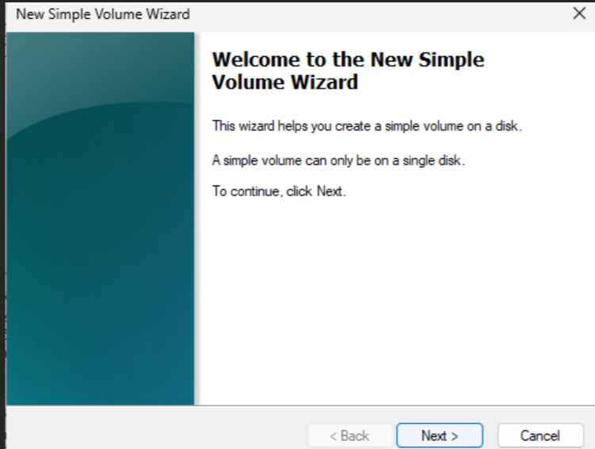
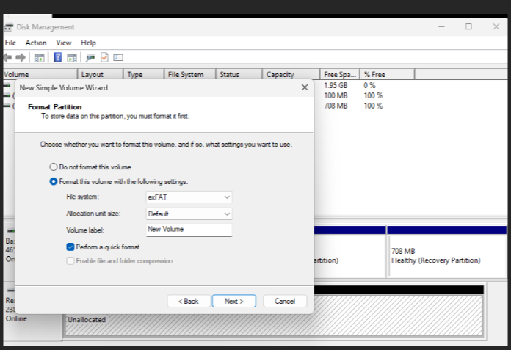
Figure 4. Partition and Format.

Next, configure the settings according to your needs, ensuring that the file system is set to exFAT/FAT32. Once configured, click 'Next' as shown in Figure 4 to complete the formatting process."

